STEP 1 – ONLAND HOME SCREEN – click on SUPPORT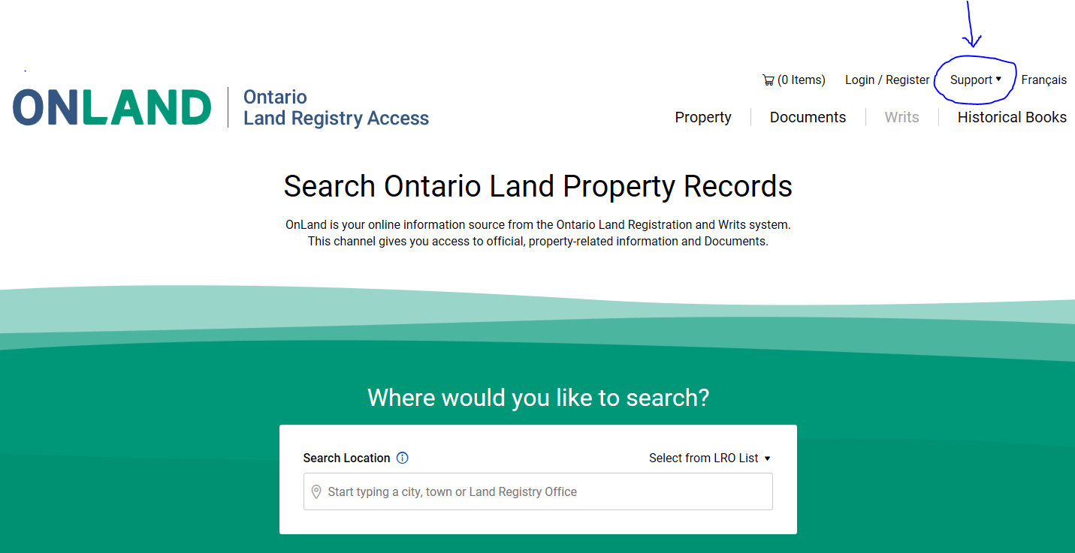

STEP 2 – DROP DOWN MENU – CLICK ON CONTACT US
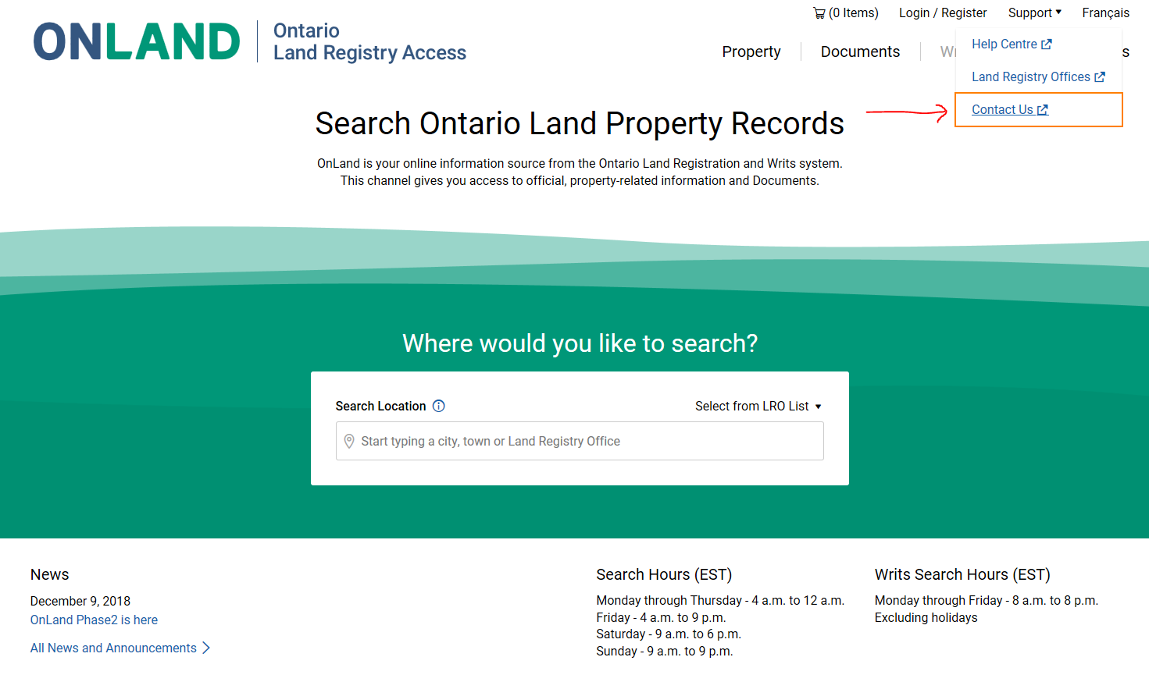

STEP 3 – CLICK ON REQUEST FORMS LINK
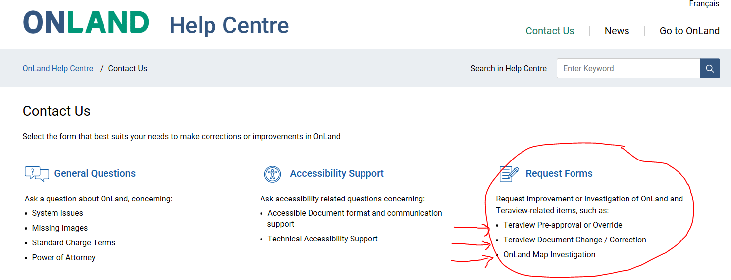

STEP 4 – CLICK ON PRE-APPROVAL OR OVERRIDE REQUEST OR CHANGE/CORRECTION
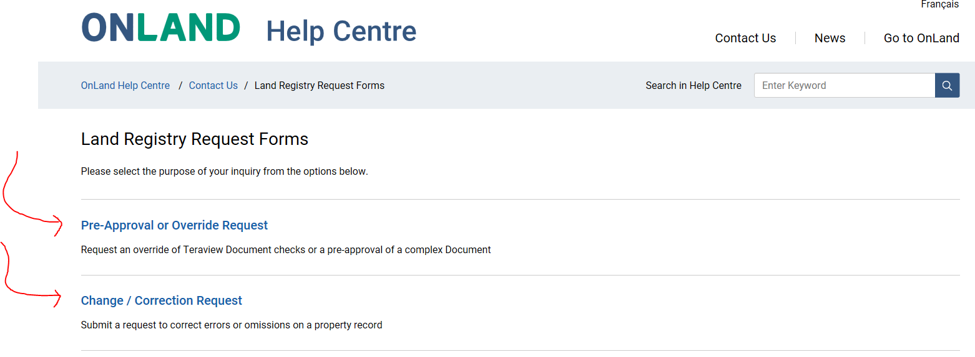

PRE-APPROVAL OR OVERRIDE SCREEN
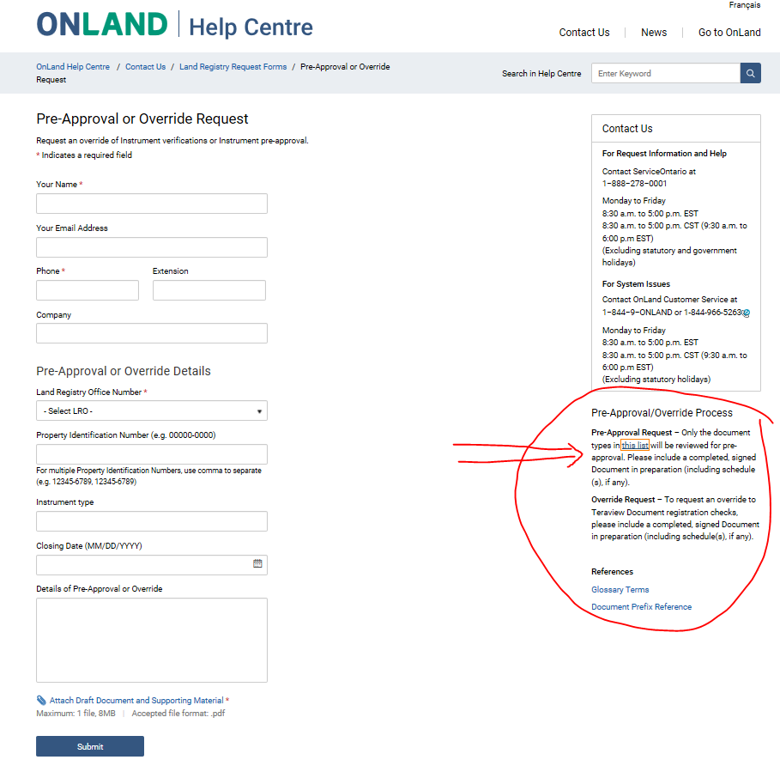

PRE-APPROVAL DOCUMENTS LIST: 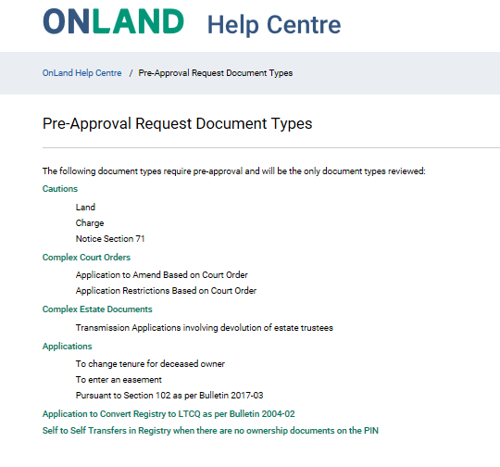

CHANGE/CORRECTION REQUEST FORM
